## CC penalty dynamic script description version 1.0

In an attempt to dynamically model the CC penalty we developed three scripts that interact with model parameters and user input values: 1) kill plants due to adverse weather conditions, 2) decrease initial plant growth via RUE reduction and 3) decrease initial root depth growth via XF reduction.

## Methodology

1. Kill plants early in the season

In the modified APSIM version, plants can be killed early in the reason due to drought stress or flooding or cold temperatures. The period that plants can be killed is from sowing to 2nd leaf (apsim 3.5 stage). The rationale for this was to account for empirical observations and experts believes wet and cold conditions are two factors that affect the CC penalty via plant loss. The model by tracking moisture and temperature dynamically can adjust plant density, while in the default version the plant density is unaffected by external authors. After extensive calibration and testing outside the study area (e.g. N Dakota, Arkansas) the following parameters recommended for use. Note that the model to kill plants, the soil moisture should be at SAT or LL for 3 days in the row and/or the minimum air temperature to be -3.5oC for two days in the row. The soil moisture is calculated for the 0-10cm depth.

Fig 1. Overview of the kill plant script as a function of moisture and temperature

Fig 2. Suggested parameter values for the kill plant script

Extra text

The script kills a portion of the plants (seeds) per day. If you have a rotation, then you have to use one script for corn and one for soy. Just duplicate the script and specify the crop name to apply the stress. Isaiah did a great job adding flexibility.

Next you specify start and end stage. Stage 1 is germination and stage 3.5 is about V3 for corn. Stage 3 is emergence for corn. If you do not know the stages just run a daily sim and check the stages. By default, we should use 1 to 3.5.

Because I do not like the daily spikes, we use a 2 or 3 day running average to estimate moisture and temp, the drivers for the kill fraction.

The second portion are the modifiers, all linked to LL, DUL, SAT values to be applicable to different soils. You can add more x-numbers and y-numbers. The x=0.5 in the above example is middle way between LL and DUL. When the 3-day running average moisture is equal to LL (EXTREMELY dry), the model will kill 3% of the plants per day. if the moisture is > LL the stress will decrease to zero at middle way between LL and DUL. If the soil is too wet, then will kill plants also. if moisture is near DUL nothing will happen. Similar story with the min temp stress. The stress starts at 2 deg C and maximized at -3.5 deg C. At 3.5 deg C will kill 1% of the plants per day. All these params are settable by the user. I suggest copy/paste these params in excel and make the XY graphs to see the shape.

Suggested values for sw and temp kill plants are:

x-moisture = 0, 0.5, 1.5, 2 and y-moisture = 0.01, 0, 0, 0.03

x-cold stress = -3.5, 0 and y-cold = 0.1, 0

Fig 3 – long term simulation of plant density with and without the kill plant rule.

1. Reduce initial plant growth via RUE

This is implemented as a 3-way interaction, multiply three stresses: residue * moisture * temperature. E.g. 1*0.9.1 = 0.9. The RUE is decreased once. The residue effect can be set to 1 and keep the other two stressors.

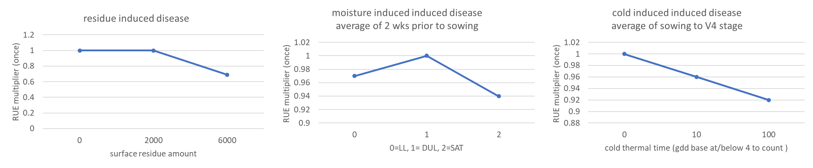

Fig 4: residue x moisture x cold stress effects on plant growth. This is to lower the initial plant growth as a result of possible diseases, which are stimulated by wet and cold conditions.

More text

This is the most complicated part because we have a 3-way interaction. To make apsim simulate “disease impacts” you have to use the other script I have in the example (name – MaizeRUElimit”. No need for extra XML code. The manager handles everything, thanks to Isaiah. The scrip is very flexible. Per Isaiah, go through the script to see what it does. Currently we consider “disease” stress on corn following corn and not on corn following soybean, but this can easily change in the script by removing the yellow portion from this line

if (stageYesterday < coldStage && LocalMaize.stage >= coldStage && prevCropMaize)

Fig 5 – the RUE script

First, specify how many days before planting to track moisture. Per Gina this is 2 weeks. Then until when to track topsoil moisture (0-5 cm). We stop tracking moisture at 1 d after planting. Then specify the layer depth to estimate the stress. We consider the top 5 cm. In my soil the layers were 0-2.5, and 2.5-5 cm layer, so I added 2 layers here. Be careful when you move the script from one sim to another as different sims have different soil layers.

The cold stress is activated from germination to stage e.g. 4 (V4 for maize). This is a proxy for Alison’s suggestion to count the number of days to reach a certain stage. The more days the higher the disease risk. We do it differently, and instead of counting days we count cold gdd. A cold gdd is 4 – tt in apsim if tt < 4 else cold gdd = 0. The higher the cold gdd the longer it will take the plant to reach a certain stage. The cold gdd threshold is set to 4 for now, you can change that. For reference the max gdd the corn can accumulate a day is 26. Here when this gets below 4 gdd/day and the crop is between planting and V4 stage then we activate the stress.

The next portion is complex. There are three multiplicative stresses - potential diseases from residue amount, moisture and cold weather. Each is a xy-pair. The first one (residue) indicates that as the surface OM weight at planting time is above 2500 kg/ha a potential disease stress is initiated and this stress becomes more severe as the surface OM increase to 10,000 kg/ha. If the surface is 10,000 kg/ha then the model will decrease the RUE or KL or XF or all by 4% (see 0.96 value). A value of 1 means no stress. Be careful here with the 1 because in the other script a value of 0 means no stress. With regards to moisture and cold stress modifiers the idea is the same. When the 14 day average moisture is high or low the model will decrease RUE or other trait by e.g. 3 to 6% if at the extremes. The cold stress is a cumulative factor. If cold-stress gdd = 0 then no stress, if 15 then 4% reduction and if 100 then 8% reduction in RUE or other trait. Again, these values are user specific. The advice is to not push the modifiers too much because the model will not behave well in Dakotas…

The script does not handle RUE, KL, XF in the same time. You will have to duplicate the script and then go to Isaiah’s code and replace “rue” with maize.KL or maize.XF.

Here is an example in which we add all the stress together, one by one. The blue is the APSIM 7.9 released version and then we add Elnaz, Heather and now Gina’s modifiers. Of course, the reduction can be much larger if we change the thresholds params.

Fig 5 – from testing of the factors.

The way the current implementation works (all stress on) is that the model will decrease CC max yield (full N) and will have a minor effect on CS yields or CC low yield (zero N)

1. Reduce root depth rate via XF

This is implemented as a 3-way interaction, multiply three stresses: residue * moisture * temperature, similarly to RUE.

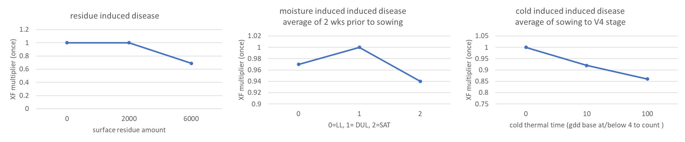

Fig 6 – suggested parameter values for the root growth limitation

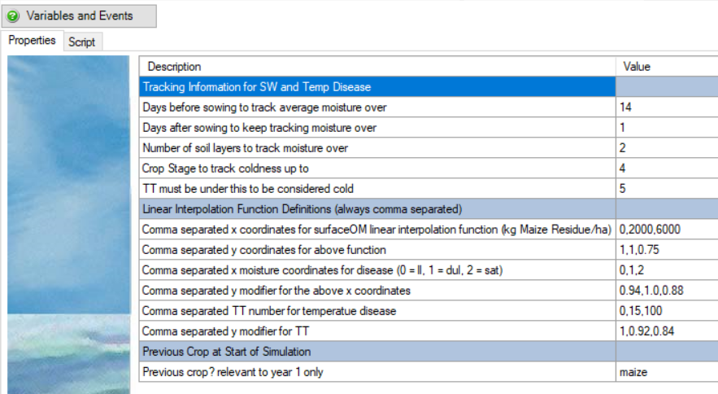

Fig 7 – the script

## Results

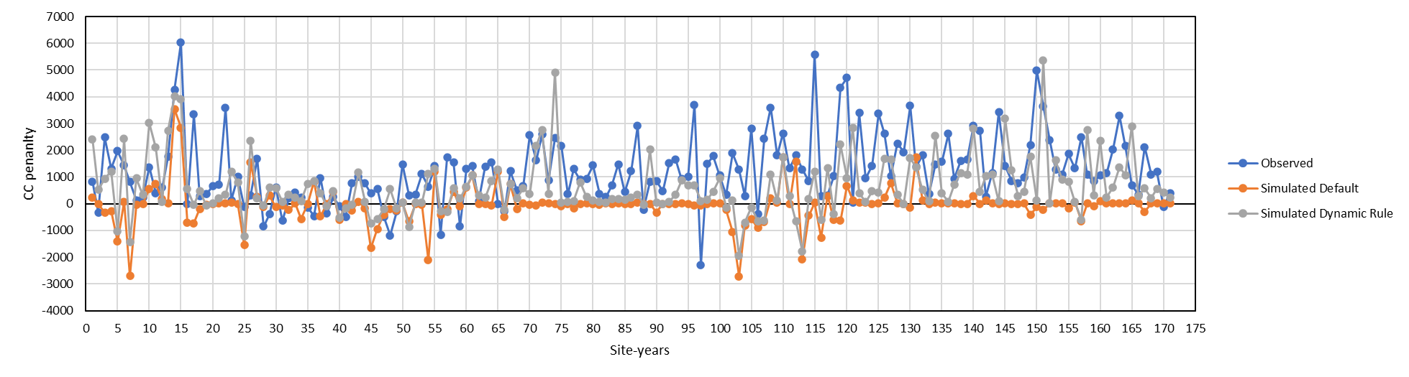

Fig 8 – application of kill plant, RUE, XF scripts in the test sets. CC penalty = CS maize yield – CC maize yield in kg/ha.

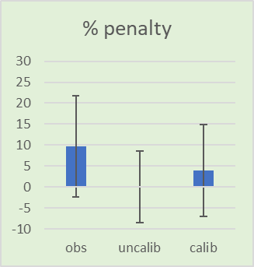

Fig 9 – summary stats. With the new scripts we made some progress, but we did not solve the problem.

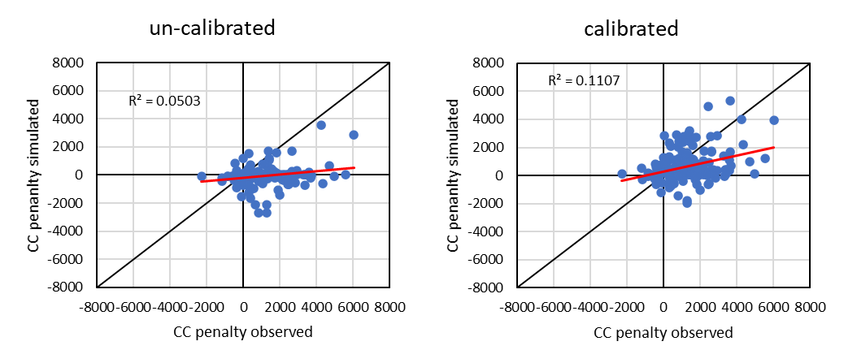

Fig 10 – simulated vs observed CC penalty before after inclusion of the dynamic scripts.

Fig 11. Simulation of the entire corn yield response to N, without and with the inclusion of the dynamic scripts.

## Conclusion

* We sacrificed some prediction accuracy to get the CC penalty (see excel)
* Significant progress made, but the problem is not yet solved.

## Where are the files:

File at: C:\Users\sarchont\Box\Mitch Long term N study\Gina LTN final

Sim at: C:\Users\sarchont\Box\Mitch Long term N study\APSIM simulations\_final

Development at: C:\Users\sarchont\Dropbox\SIMULATIONS_REV_3899_PSIMS_shared\installer\NEW modification to 7.9 maize